Phase I and Phase II Results – Texas (TX)

A. Introduction

B. Plot of Lagged Predictors vs. HPI (simple returns)
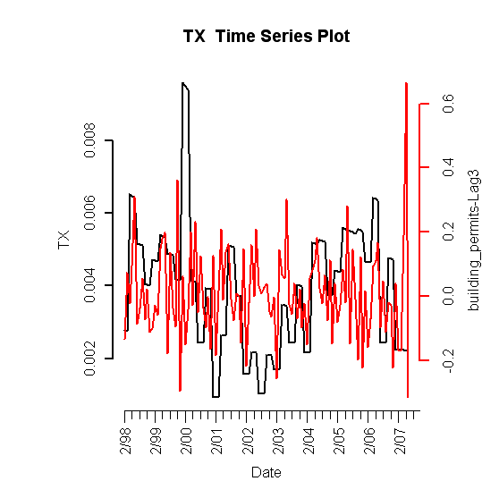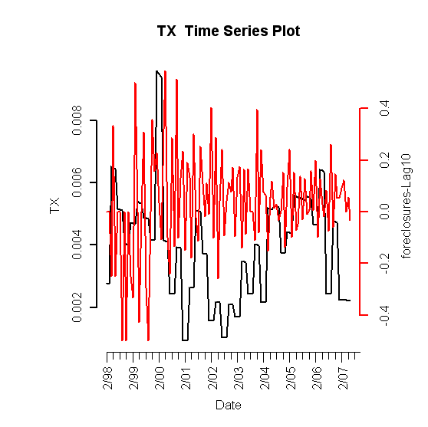
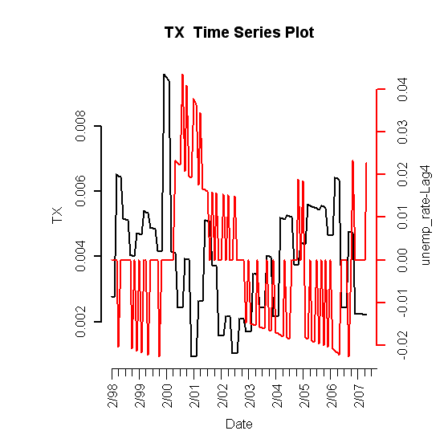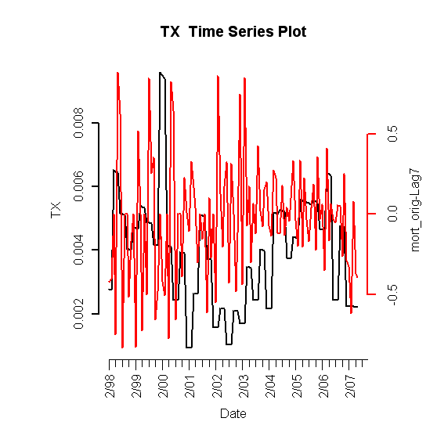
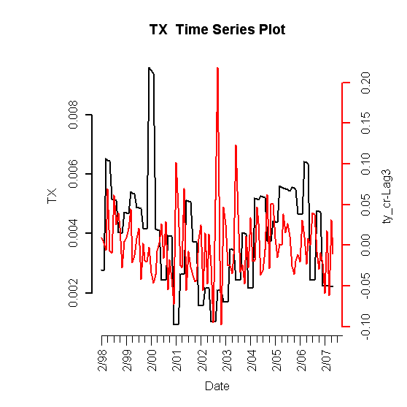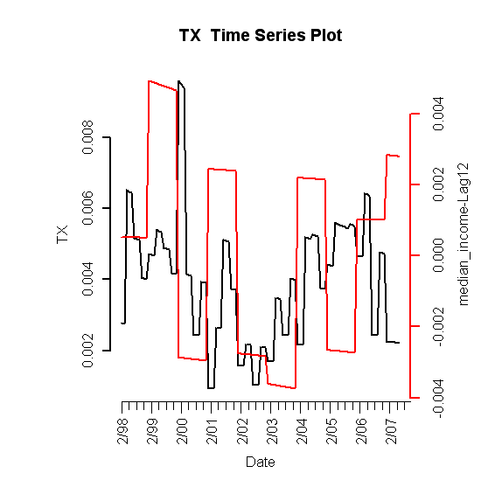
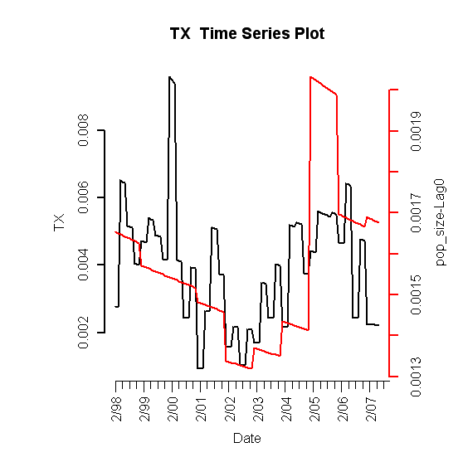

Figure I.1: Lagged predictors vs. Texas HPI

C. Final Multivariate Model

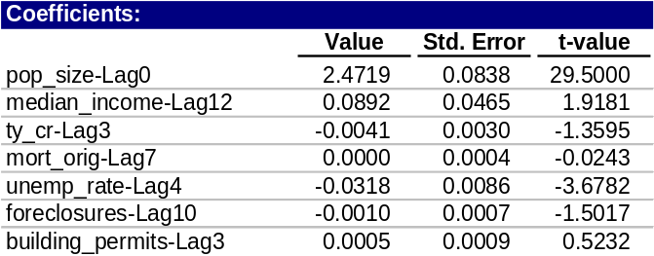
Table 1: Fitted drift model

1. Phase I: Drift Model
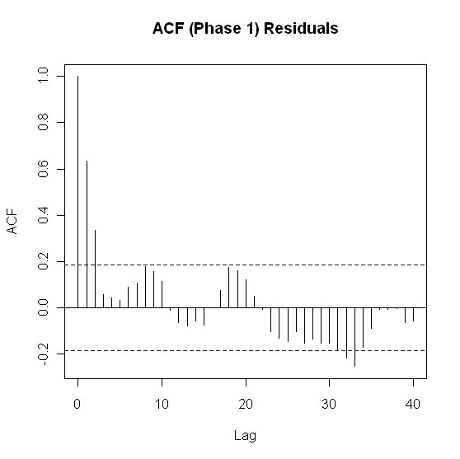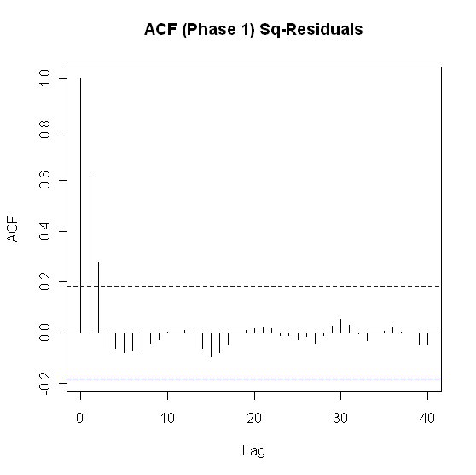

Figure I.2: ACF of residuals (left) and squared residuals (right) of fitted linear model

2. Phase II: Volatility Model

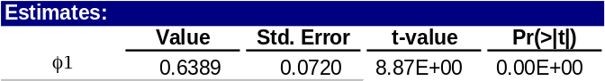
Table 2: Texas fitted volatility model
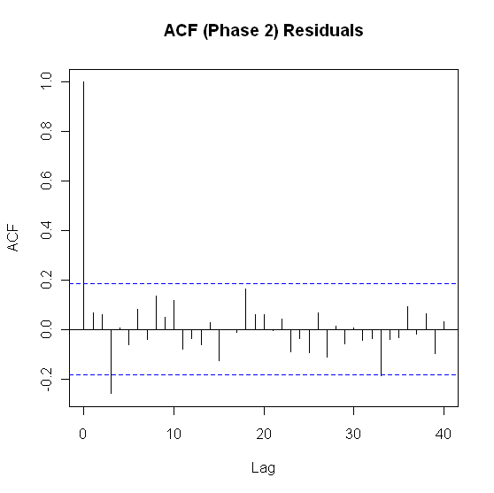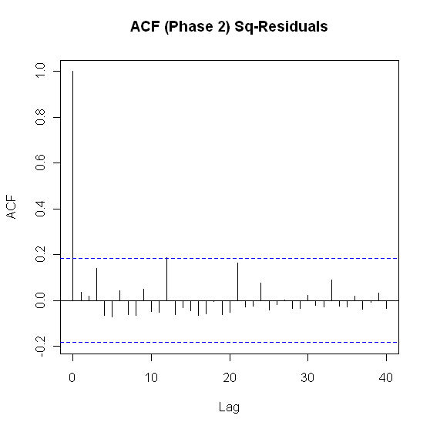

Figure I.3: ACF of residuals (left) and squared residuals (right) of the Phase II model for Texas

3. Model Checking Diagnostics
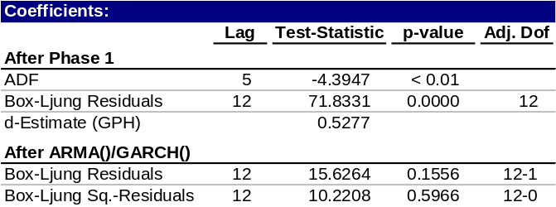
Table 3: Statistical test results for complete model

D. Fitted vs. Actual Plots

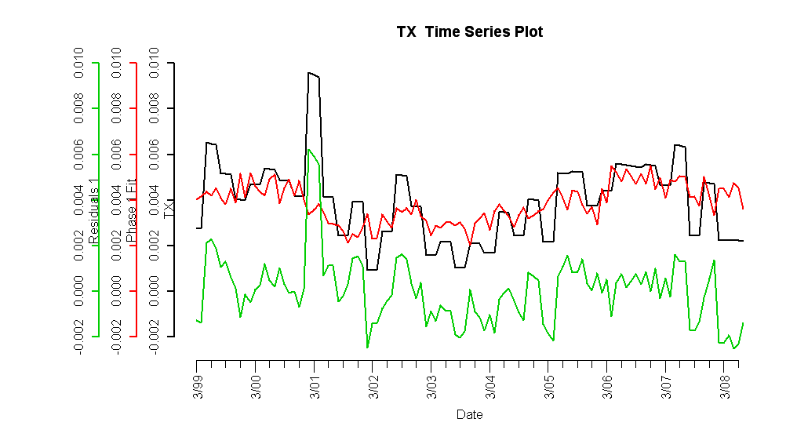

Figure I.4: Fitted Phase I vs. Texas HPI and residuals

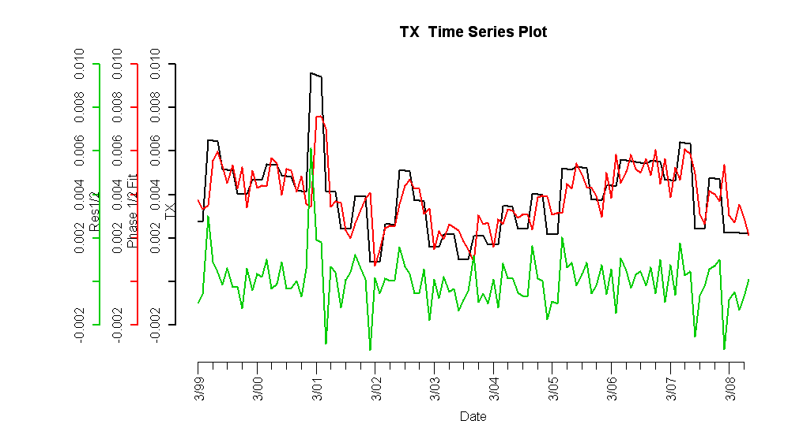

Figure I.5: Complete fitted model vs. Texas HPI and residuals
E. Forecasts

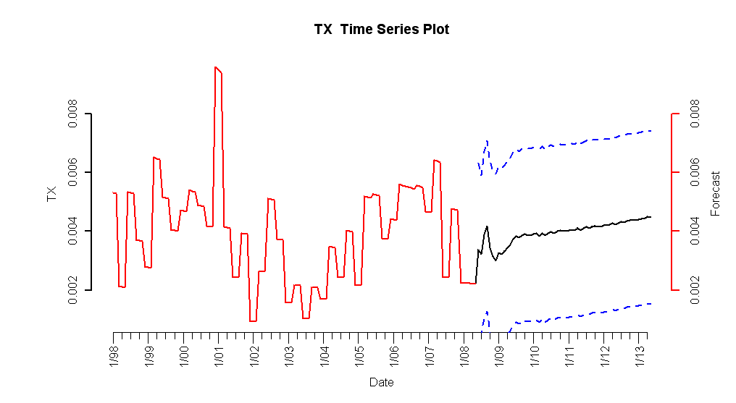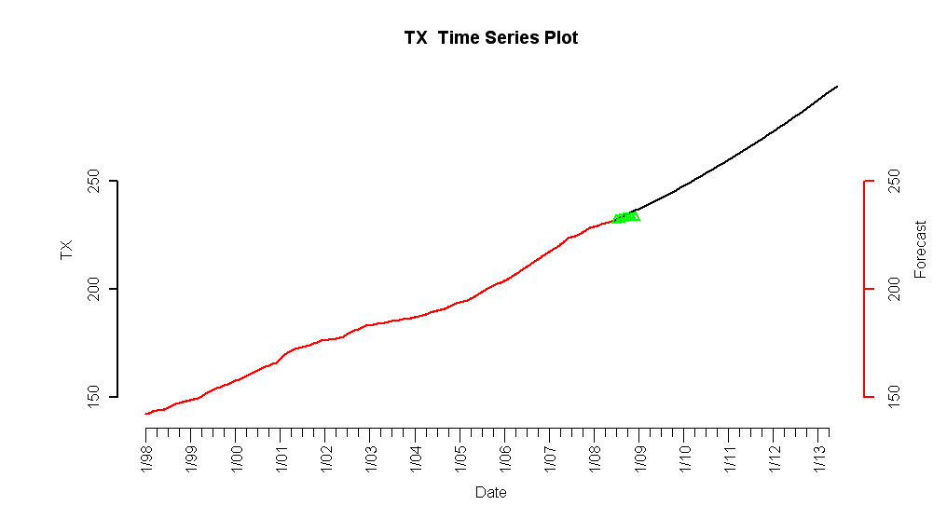
Figure I.6: 5-year forecasted simple returns (top) and forecasted HPI (bottom)

F. Interpretation of Forecasts

